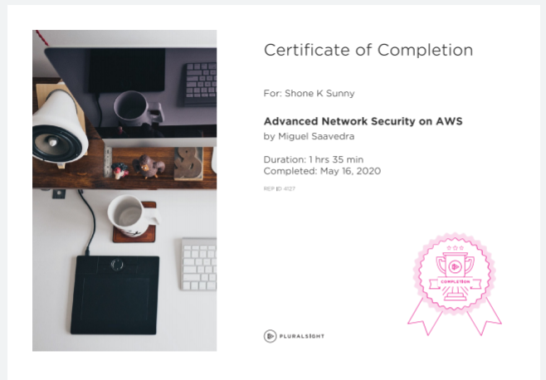

Successfully completed course on Advanced Network Security on AWS